Project 6-3: Installing NoxPlayer Android Emulator
Estimated Time: 20 minutes
Objective: Install an Android emulator.
Description: In this project, you install an Android emulator on a personal computer.
- Use your web browser to go to www.bignox.com. (The location of content on the Internet may change without warning. If you are no longer able to access the program through this URL, use a search engine and search for “NoxPlayer”.)
- Download the latest version of NoxPlayer.
- When the download is complete, launch the installation file and accept the defaults to install the software.
- Launch NoxPlayer.
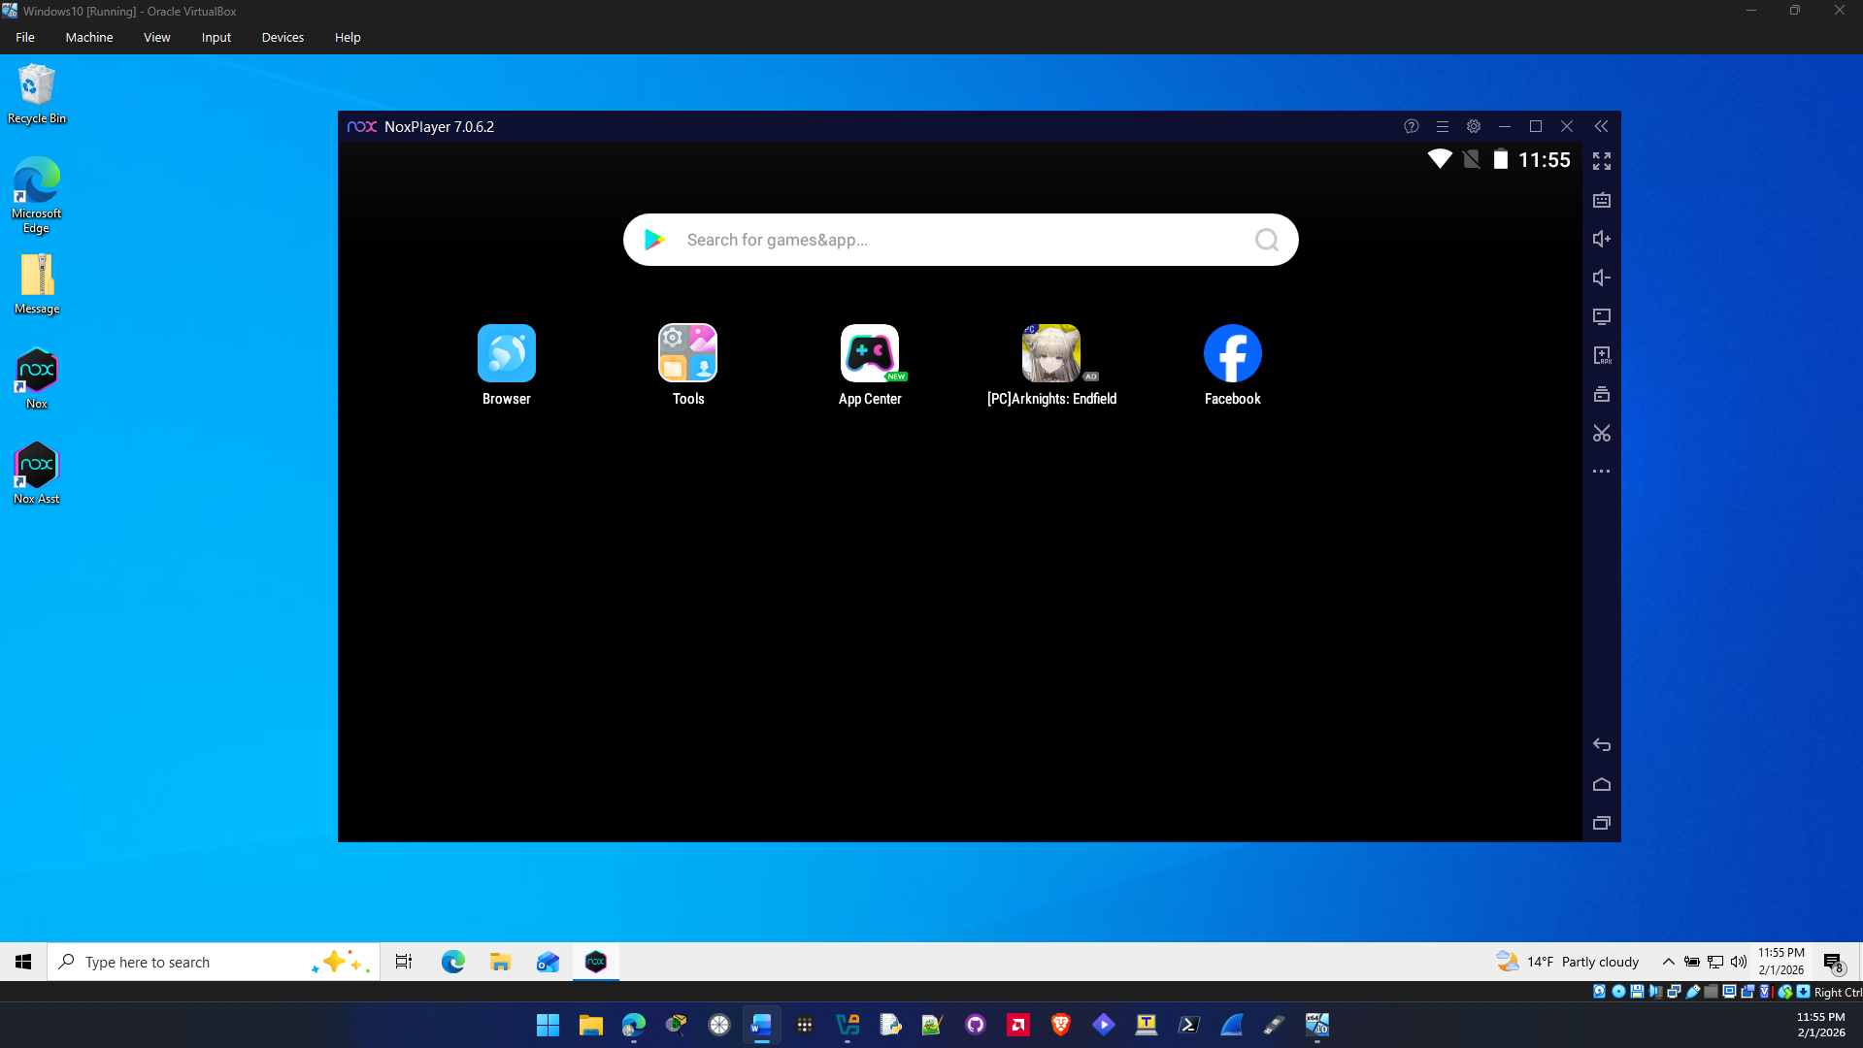

- Click the System settings icon.
- Under Performance settings, click the down arrow to view the different options.
- Under Resolution setting, change from the default Tablet to Mobile phone. What are the screen resolutions now?
The screen resolutions after you change from tablet to mobile phone are 2160x3840, 1440x2560, 1080x1920, 900x1600, 720x1280, 540x960 The resolutions flipped dimensions.

- Click Device.
- Click the down arrow under Mobile phone model and select a different mobile phone to emulate.
- How could this application be used for software testing? Are the features easy to use? What suggestions do you have for improvement?
It can be used for testing because it allows you to test apps across different android versions and different devices all in one application. The features are easy to use and the ui is easy to navigate. The suggestions I would have for improvement would be better support for performance in virtual machines it was very slow on my VM even with all the vt tech enabled and graphics settings on. Maybe redue the amount of ads on the ui and make it a little more barebones so it can run smoother in a virtual environment.

- Close all windows.

Criteria | Meets Requirements | Needs Improvement | Incomplete
Content | The assignment clearly and comprehensively addresses all questions in the assignment.  15 points | The assignment partially addresses some or all questions in the assignment.  8 points | The assignment does not address the questions in the assignment.  0 points
Organization and Clarity | The assignment presents ideas in a clear manner and with strong organizational structure. The assignment includes appropriate content, coverage of facts, arguments, and conclusions.  10 points | The assignment presents ideas in a mostly clear manner and with some organizational structure. The assignment includes appropriate content, coverage of facts, arguments, and conclusions.  7 points | The assignment does not present ideas in a clear manner or with a strong organizational structure. The assignment includes some appropriate content, but coverage of facts, arguments, and conclusions are not logically related and consistent.  0 points
Research | The assignment is based upon appropriate and adequate data collection and analysis of results from the activity or research from academically reliable sources.  5 points | The assignment is based upon adequate data collection and includes some analysis of results from the activity or research from academically reliable sources.  3 points | The assignment is not based upon appropriate data collection and includes no analysis of results from the activity or research from academically reliable sources.  0 points
Grammar and Spelling | The assignment has two or fewer grammatical and spelling errors.  5 points | The assignment has three to five grammatical and spelling errors.  3 points | The assignment has more than five grammatical and spelling errors, is incomplete, or is unintelligible.  0 points

